Ideation Phase
Empathize & Discover

Date | 20 October 2026
Team ID | Niharika Suhane
Project Name | IMovies - Movie ticket booking made simple.
Maximum Marks | 4 Marks

Empathy Map Canvas:
Understand the needs, frustrations, and behaviors of moviegoer seeking 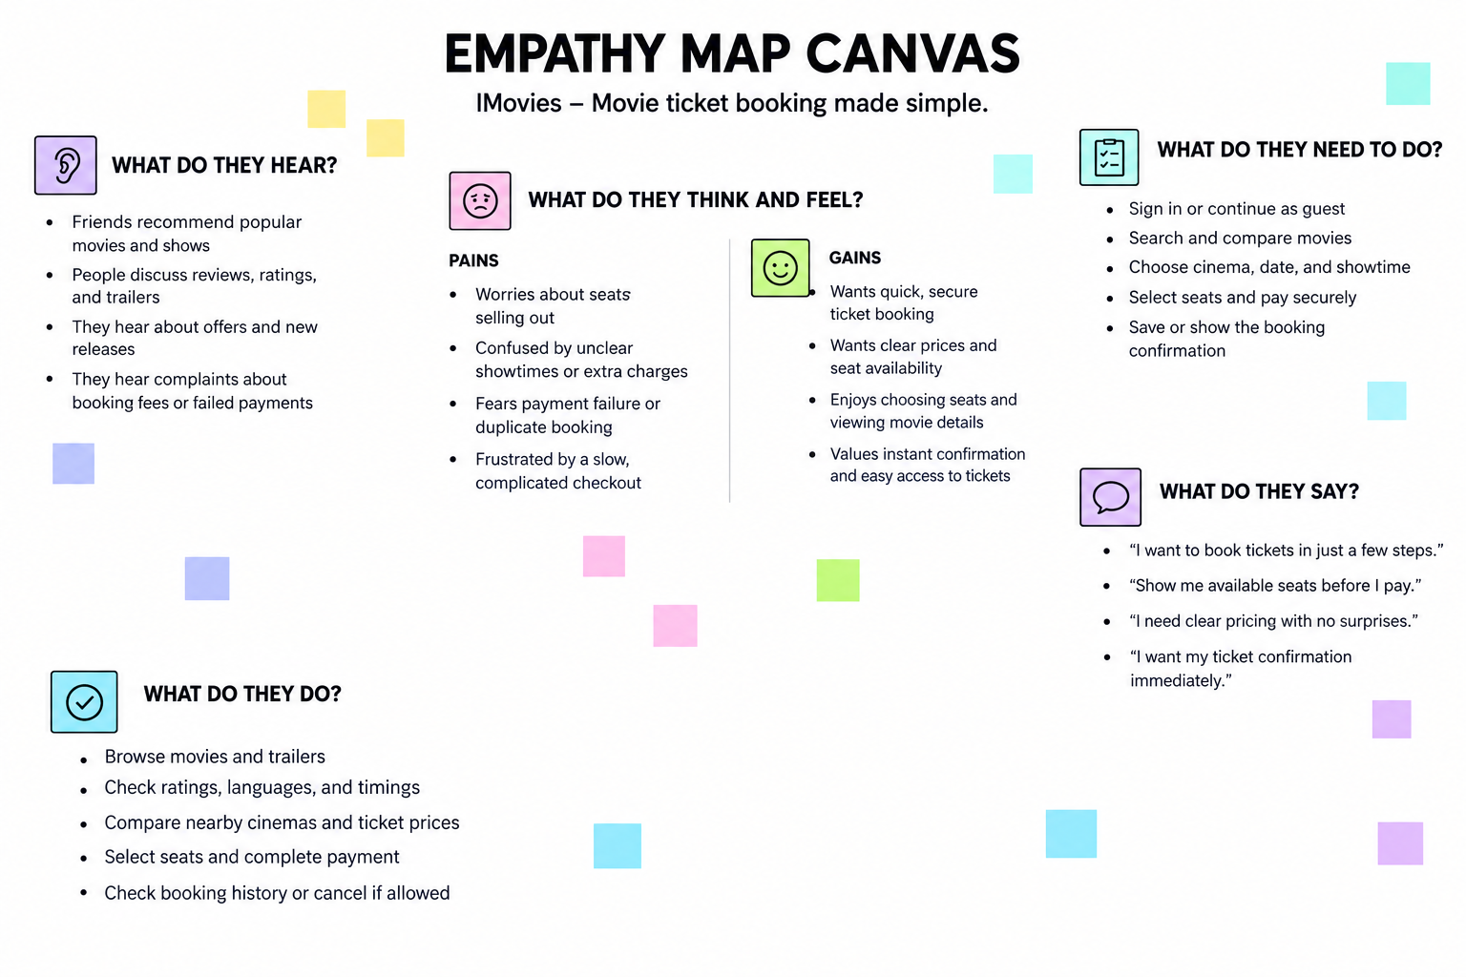a smooth consistent and hassle-free ticket booking experience through a platform like IMovies.

Reference: https://www.mural.co/templates/empathy-map-canvas

